**Project Design Phase-II**

**Data Flow Diagram & User Stories**

|  |  |
| --- | --- |
| Date | 03 October 2022 |
| Team ID | PNT2022TMID04604 |
| Project Name | Project – PLASMA DONOR APPLICATIONS |
| Maximum Marks | 4 Marks |

**Data Flow Diagrams:**

A Data Flow Diagram (DFD) is a traditional visual representation of the information flows within a system. A neat and clear DFD can depict the right amount of the system requirement graphically. It shows how data enters and leaves the system, what changes the information, and where data is stored.

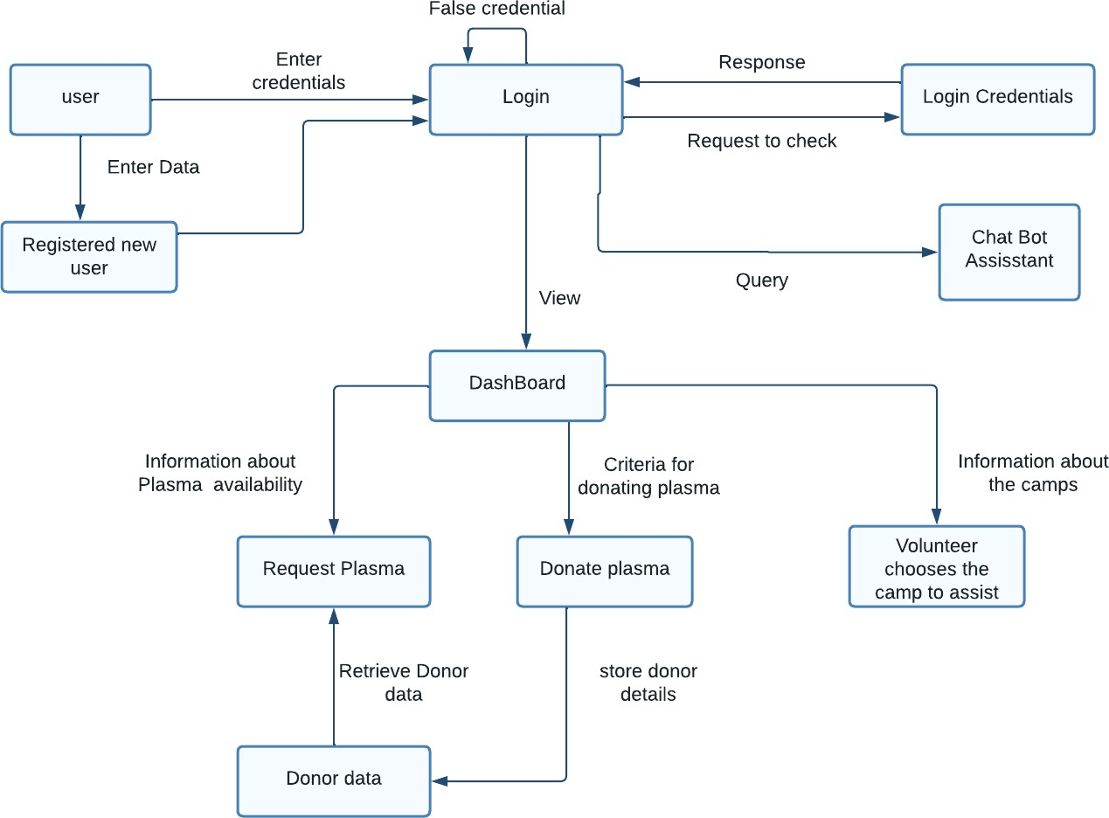

**User Stories**

Use the below template to list all the user stories for the product.

|  |  |  |  |  |  |  |
| --- | --- | --- | --- | --- | --- | --- |
| **User Type** | **Functional Requirement**  **(Epic)** | **User Story Number** | **User Story / Task** | **Acceptance criteria** | **Priority** | **Release** |
| Customer (Mobile user) | Registration | USN-1 | As a user, I can register for the application by entering my email, password, and confirming my password. | I can access my account / dashboard | High | Sprint-1 |
|  |  | USN-2 | As a user, I will receive confirmation email  once I have registered for the application | I can receive confirmation  email & click confirm | High | Sprint-1 |
|  |  | USN-3 | As a user, I can register for the application through Gmail | I can receive confirmation notifications through Gmail | Medium | Sprint-1 |
|  | Login | USN-4 | As a user, I can log into the application by  entering email & password | I can access into my User  profile and view details in dashboard | High | Sprint-1 |
|  | Dashboard | USN-5 | As a user,I can send the proper requests to  donate and obtain plasma. | I can receive appropriate  notifications through email | High | Sprint-1 |
| Customer (Web user) | Login | USN-6 | As a user,I can register and log into the application by entering email & password to  view the profile | I can access into my User profile and view details in  dashboard | High | Sprint-1 |
|  | Dashboard | USN-7 | As a user,I can send the proper requests to donate and obtain plasma. | I can receive appropriate notifications through email | High | Sprint-1 |
| Customer Care  Executive | Application | USN-8 | As a customer care executive,I can try  address user’s concerns and questions | I can view and address  their concerns and questions | Medium | Sprint-2 |
| Administrator | Application | USN-9 | As an administrator I can help with user-facing aspects of a website, like its appearance, navigation and use of media. | I can change the  appearance and navigation in a user friendly manner | Medium | Sprint-3 |
|  |  | USN-10 | As an administrator, I can involve working with the technical side of websites. | I can help with such as  troubleshooting issues, setting up web hosts, ensuring users have access and programming servers | Medium | Sprint-1 |
| User Type | Functional Requirement  (Epic) | User Story Number | User Story / Task | Acceptance criteria | Priority | Release |
| Chatbot | Dashboard | USN-11 | In addition the customer care executive  ,chatbot can try to address user’s  concerns and questions | I can reply to all the queries related to our  application | Medium | Sprint-3 |